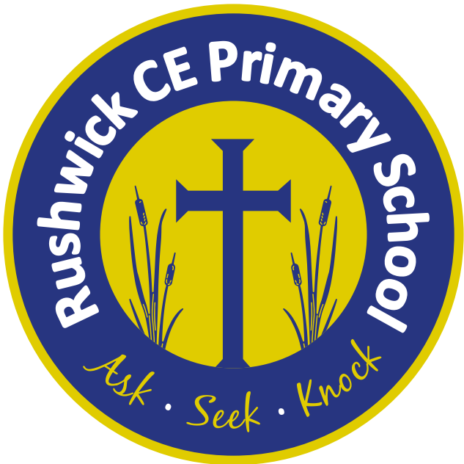
Rushwick CE Primary School: 2026-2027 Long Term Plan
Year 6
 | Autumn 1 | Autumn 2 | Spring 1 | Spring 2 | Summer 1 | Summer 2
Key English text(s) | Floodland by Marcus Sedgwick | One Boy's War by  Lynn Huggins-Cooper and Ian Benfold Haywood | Oliver Twist by Charles Dickens | Corey’s Rock by Sita Brahmachari | Boy 87 by Ele Fountain | The Lost Words by Robert Macfarlane
Class novel | Harry Potter and the Philosophers Stone by J.K. Rowling |  | The Explorers by Katherine Rundell |  | Whispering to Witches by Anna Dale
Reading Gems Texts | Journey to the River Sea by Eva Ibbotson | Letters from the Lighthouse by Emma Carroll | The Tulip Touch by Anne Fine | Mixed Comprehensions  (SATS Revision) | Mixed Comprehensions  (SATS Revision) | The Garbage King by Elizabeth Laird  Sky Song by Abi Elphinstone
Poems
Maths - White Rose | - Place value  - Addition, subtraction, multiplication and division | - Fractions A  - Fractions B  - Measurement: Converting units | - Ratio  - Algebra  - Decimals | - Fractions, decimals and percentages  - Area, perimeter and volume  - Statistics | - Shape  - Position and direction | - Themed projects, consolidation and problem solving
Science | Living things: Classifying big and small | Energy: Light and reflection | Living things: Evolution and inheritance | Electricity: Circuits, batteries and switches | Animals, including humans: Circulation and health | Making Connections: Are some sunglasses safer than others?
Geography |  | Our changing World |  | The Amazing Americas | Heritage Project
History | Crime and Punishment |  | WW2 |  | Heritage Project
Music | Dynamics, pitch and texture: (Theme: Coast – Fingal’s Cave by Mendelssohn) | Theme and Variation: (Theme: Pop Art) | Keyboard | Keyboard | Baroque | Composing and performing a leavers song.
Art | Craft and design:  Photo opportunity |  | Drawing:  Make my voice heard |  | Sculpture and 3D:  Making memories
D.T. |  | Electrical Systems: The Steady Hand Game |  | Structures: Build a playground |  | Textiles: Design a stuffed toy  Cooking and Nutrition: Come Dine with Me
Computing | Communication and collaboration | Webpage creation | Programming A - Variables in Games | Introduction to spreadsheets | 3D modelling | Programming B - Sensing movement
R.E. | U2.4 Christians and how to live: ‘What would Jesus do?’ | U2.7 Why do Hindus want to be good? | U2.2 Creation and science: conflicting or complementary? | U2.6 For Christians, what kind of king is Jesus? | U2.10 What matters most to Humanists and Christians? (C, M/J, NR) | U2.14 What do religious and non-religious worldviews teach about caring for the Earth?
P.S.H.E. | Assertiveness  Cooperation  Safe/unsafe touches  Positive relationships  Recognising and celebrating difference | Recognising and reflecting on prejudice-based bullying  Understanding bystander behaviour  Gender stereotyping | Understanding emotional needs  Staying safe online  Drugs: norms and risk (including the law) | Understanding media bias  Caring: communities and the environment  Understanding democracy | Aspirations and goal setting  Managing risk  Looking after my mental health | Coping with changes  Keeping safe  Body image  Sex education  Self esteem
French | Review Y3. Y4 and Y5  The time | Daily routine  Physical description | Personality  Clothes | In the city and directions | Snacks and drinks at the cafe | Occupations/  professions
P.E./Games | Swimming  Hockey | Tag Rugby  Dance | Gymnastics  Netball | Cricket  Dodgeball | Handball  Athletics | Basketball  Rounders

