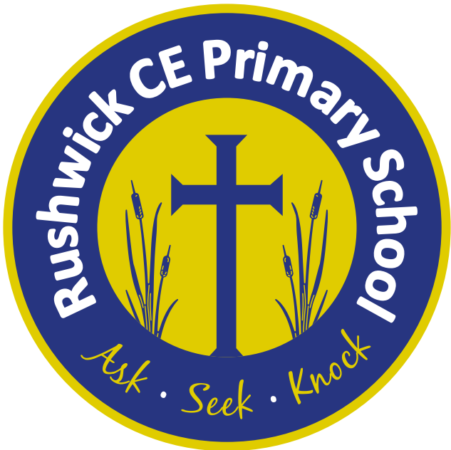
Rushwick CE Primary School: 2026-2027 Long Term Plan
Year 5 English and Maths Long Term Plan / Year 4/5 Foundation Long Term Plan
 | Autumn 1 | Autumn 2 | Spring 1 | Spring 2 | Summer 1 | Summer 2
Key English text(s) | Rooftoppers by Katherine Rundell | The Boy at the Back of the Class by Onjali Q. Raúf | Viking Boy by Tony Bradman | Skellig by David Almond | Survivors by David Long | War Horse by Michael Morpurgo
Class novel | Max and the Millions by Ross Montgomery | The Miraculous Journey of Edward Tulane by Kate DiCamillo | The Boy in the Tower by Polly Ho-Yen |  | The Lion Above the Door by Onjali Q. Raúf [TBC]
Reading Gems Texts | The Amazing Story of Adolphus Tips by Michel Morpurgo | Varjak Paw by S.F Said | Pig Heart Boy by Malorie Blackman | Coraline by Neil Gaiman | October, October by Katya Balen | No Ballet Shoes in Syria by Catherine Bruton
Poems | Jabberwocky by  Lewis Carroll | In Flanders Fields by John McCrae | Life Doesn’t Frighten Me by Maya Angelou | Daffodils by  William Wordworth | Nature Trail by Benjamin Zephaniah | Sonnet 18 by William Shakespeare
Maths - White Rose | Place value  Addition and Subtraction  Multiplication and division A  Fractions A |  | Multiplication and division B  Fractions B  Decimals and percentages  Perimeter and area  Statistics |  | Shape  Position and Direction  Decimals  Negative Numbers  Converting units  Volume
Science | Materials: Mixtures and separation  Materials: Properties and change |  | Forces and space: Earth and space  Living things: Lifecycles and reproduction |  | Forces and space: Unbalanced forces  Animals: Human timeline/ Making connections
Geography |  | Exploring Eastern Europe |  | Magnificent Mountains | Enough for Everyone
History | Vikings and Anglo-Saxon |  | Maya Civilisation |  |  | Heritage Project:  Changes to people and jobs
Music | Composition notation (Theme: ancient Egypt)  Blues |  | Keyboard |  | South and West Africa  Composition to represent the festival of colour (Theme: Holi festival)
Art | Sculpture and 3D: Interactive installation |  | Painting and mixed media: Portraits |  | Drawing: I need space
D.T. |  | Mechanisms: Pop-up books |  | Electrical systems: Doodlers |  | Cooking and Nutrition: Pasta sauce.
Computing | Systems and searching  Video production |  | Selection in physical computing  Flat-file databases |  | Vector graphics  Selection in quizzes
R.E. | What does it mean if Christians believe God is holy and loving?  Why do Christians believe Jesus was the Messiah? |  | What does it mean to be a Muslim in Britain today?  Why is the Torah so important to Jewish people? |  | What does it mean to be a Humanist in Britain today?  What can be done to reduce racism? Can religion help?
P.S.H.E. | AYLA  Valuing difference |  | Keeping safe  Rights and respect |  | Being my best  Growing and changing
French | Review Y3 and Y4  Emotions  Body parts  At the doctors |  | Countries and cities  Travel around the world  French speaking countries  Nationality and languages |  | Numbers 50-100  Money  At the supermarket
P.E./Games | Tag Rugby  Basketball | Gymnastics  Netball | Dance  Swimming | Swimming  Handball | Tennis  Cricket | Athletics  Rounders

