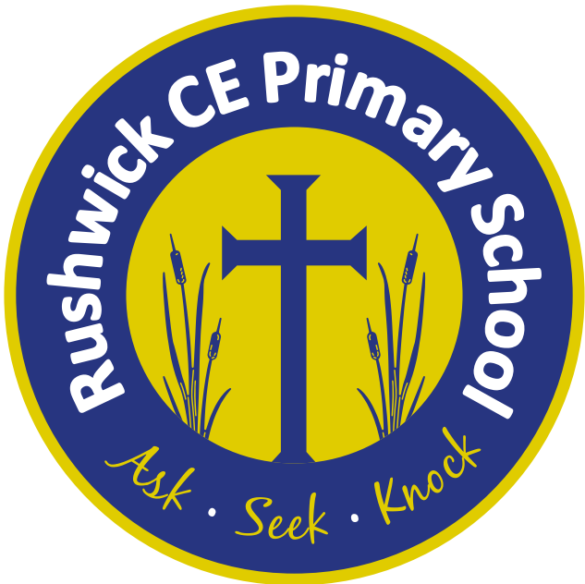
Rushwick CE Primary School: 2026-2027 Long Term Plan
Year 4
 | Autumn 1 | Autumn 2 | Spring 1 | Spring 2 | Summer 1 | Summer 2
Key English text(s) | - Instructions for a Magic Spell (GS model text)  - Diary of a Rich Roman (GS model text) | - The Evil Queen Biography (GS model text)  - Fairytales: The Villain’s version by Kaye Umansky  - Journey to the North Pole Coca-Cola Christmas advert (LitShed) | - Pegasus non-chronological report (GS model text)  - Echidna: Mother of Monsters non-chronological report (GS model text)  - Join Theseus to Slay the Minotaur persuasive advert (GS model text) | - The Rainforest setting description (GS model text)  - The Day the Crayons Came Home by Drew Daywalt (LitShed) | - Lights on Cotton Rock by David Litchfield (LitShed)  - My Name is not Refugee by Kate Milner | - Ocean Meets Sky by The Fan Brothers (LitShed)
Class novel | The Wild Robot by Peter Brown | The Wild Robot by Peter Brown | Harry Potter and the Philosophers Stone by J.K. Rowling | Harry Potter and the Philosophers Stone by J.K. Rowling | The Land of Roar by Jenny McLachlan | The Land of Roar by Jenny McLachlan
Reading Gems Texts | The Wild Robot by Peter Brown | The Wild Robot by Peter Brown | The Worst Witch by Jill Murphy | The Barnabus Project by The Fan Brothers | The Butterfly Lion by Michael Morpurgo | The Sheep Pig by Dick King-Smith
Poems | I am a Roman Soldier by Josiah Wedgewood  Various Kenning Poems
Maths - White Rose | - Place value  - Addition and subtraction | - Measurement: Area  - Multiplication and division A | - Multiplication and division B  - Measurement: Length and perimeter | - Fractions  - Decimals A | - Decimals B  - Measurement: Money | - Measurement: Time  - Geometry: Shape  - Statistics  - Geometry: Position and direction

