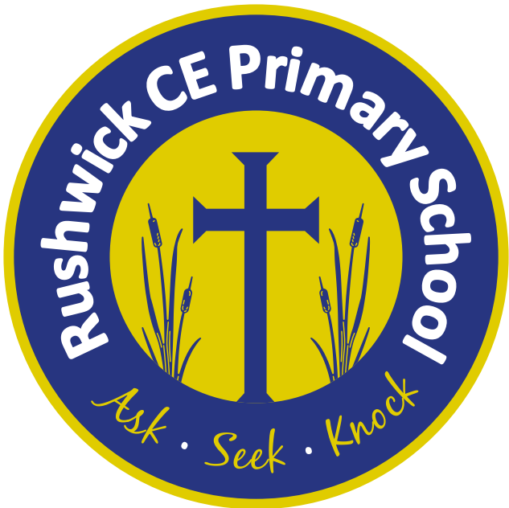
Rushwick CE Primary School: 2026-2027 Long Term Plan
Year 3
 | Autumn 1 | Autumn 2 | Spring 1 | Spring 2 | Summer 1 | Summer 2
Key English text(s) | A River by Marc Martin  Blue John by Berlie Doherty | Flotsam by David Wiesner  A Cautionary Tale about chocolate by David Lucas | Arthur and the Golden Rope by Joe Todd-Stanton  The King Who Banned the Dark by Emily Haworth-Booth | The Last Bear by Hannah Gold  Song of the River by Gill Lewis | The Tin Forest by Helen Ward  Revolting Rhymes by Roald Dahl | Nell and the Cave Bear by Martin Brown  Malala’s Magic Pencil by Malala Yousafzai
Class novel | Stig of the Dump by Clive King | The Wild Robot by Peter Brown  The Hodgeheg – Dick King Smith | Planet Omar by Zanib Main | The Boy who grew dragons by Andy Shepherd | I Am Lenny Brown by Dan Freedman | The Day I fell into a Fairytale by Ben Millar
Reading Gems Texts | Stone Age Boy by Satoshi Kitamura  Iron Man by Ted Hughes | Why the Whales Came by Michael Morphurgo | Fantastic Mr Fox by Roald Dahl | I believe in Unicorns by Michael Morphurgo | King Kong By Anthony Browne | The Ice Palace by Robert Swindells
Poems | If I Were King  By A.A Milne | How the Grinch Stole Christmas by Doctor Seuss | Beautifully Different, Wonderfully the Same - Joseph Coelho | ‘All the worlds alive again’- Jennifer Gunner. | I Raised My Hand In Class | The Ning Nang Nong – Spike Milligan
Maths - White Rose | Place Value  Addition & Subtraction | Addition & Subtraction continued  Multiplication & Division | Multiplication and Division  Length and Perimeter | Fractions  Mass and Capacity | Fractions  Money  Time | Time (Continued)  Shape  Statistics
Science | Animals: Movement and nutrition | Forces and space: Forces and magnets | Materials: Rocks and soil | Energy: Light and shadows | Plants: Plant reproduction | Making connections: Does hand span affect grip strength?
Geography |  | Extreme Earth |  | The United Kingdom | Heritage Project Focus: Malvern  Rushwick/Worcester within the UK
History | Stone Age to Iron Age |  | The Ancient Egyptians |  | Heritage Project Focus: Malvern  Rushwick/Worcester within the UK
Music | Ballads | Creating compositions in response to an animation (Theme: Mountains) | Ukelele | Ukelele | Pentatonic melodies and composition Theme: Chinese New Year Jazz | Traditional instruments & improvisation  Theme: India
Art | Painting and mixed media – prehistoric art |  | Egyptian Scroll – making Papyrus paper and decorating with Egyptian symbols. |  | Sculpture & 3D: Abstract shape
D.T. |  | Wearable technology |  | Structures: Constructing a castle |  | Cooking and nutrition: Eating seasonally
Computing | 1. Computing systems and networks – Connecting computers | 2. Creating media - Stop-frame animation | 3. Programming A - Sequencing sounds | 4. Data and information – Branching databases | 5. Creating media – Desktop publishing | 6. Programming B - Events and actions in programs
R.E. | L2.2 What is it like for someone to follow God? | L2.10 How do festivals and family life show what matters to Jewish people? | L2.1 What do Christians learn from the Creation story? | L2.9 How do festivals and worship show what matters to a Muslim? | L2.4 What kind of world did Jesus want? | L2.12 How and why do people try to make the world a better place?
P.S.H.E. | Me and My Relationships | Valuing Difference | Keeping Safe | Rights and Respect | Being my Best | Growing and Changing
French | Greetings and name | Classroom instructions  French alphabet | Numbers 0 to 20 | The Colours  Numbers 20 to 50 | The Date and Birthday  The Hungry Caterpillar | My Family  At the Farm
P.E./Games | Hockey  Fundamentals | Tag Rugby  Fitness | Dance  Football | Cricket  Gymnastics | Tennis  Netball | Athletics  Basketball

