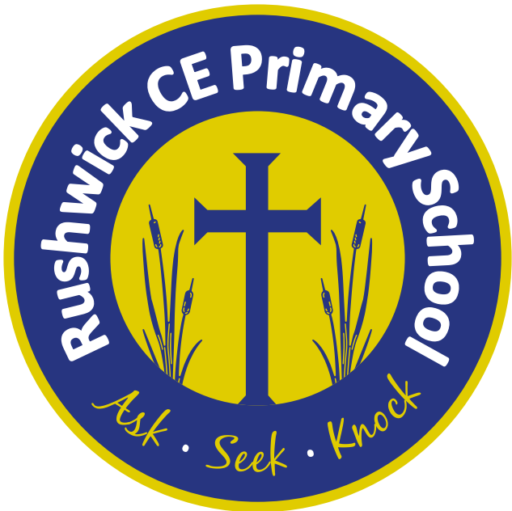
Rushwick CE Primary School: 2025-2026 Long Term Plan
Year 6
 | Autumn 1 | Autumn 2 | Spring 1 | Spring 2 | Summer 1 | Summer 2
Key English text(s) | Straw into Gold  How the Whale Became | Extreme Animals  The Call | Tear Thief  Letters from the Lighthouse | Secret War Diary  Persuasive Argument to Visit Mexico (GS) | Animalium  Should Children do SATS? | The Tale of the Three Brothers  Cloud Busting
Class novel | The Nowhere Emporium | The Nowhere Emporium | The Titanic Detective Agency | Letters from the Lighthouse | The Explorer | The Explorer  Tales from Beadle the Bard
Reading Gems Texts | Desert Creatures  Desert Biomes  Cyberbullying  Medusa  Katherine Ferrers  Julius Caesar | Diwali Dreams  The Bonfire at Night  Gothic Fiction Characters  Maya  A Christmas carol: Marley’s ghost  Bob Cratchit’s house | A Gunner’s day  The Little Smuggler  Reginald Joseph Mitchell  World War II | Imports and Exports of the UK  Biomes of the world  A day in the life of a Cardiologist  A day in the life of a Pharaoh | The Listeners  The Scarecrow  New species discovered in the Galapagos  Moon landing | Visit the Galapagos  Waste Water Management  Migration to the UK  Windrush Passenger  Hamlet  Macbeth
Poems | The Mock Turtle’s Song by Lewis Carroll | The Tyger by William Blake | Everyone Comes From Somewhere by Michael Rosen | Star by Michaela Morgan | The Night Walker by Philip Gross | River Reflection by Jackie Kay
Maths - White Rose | Place value  Addition, subtraction, multiplication and division | Fractions A  Fractions B  Converting units | Ratio  Algebra  Decimals | Fractions, decimals and percentages  Area, perimeter and volume  Statistics | Revision for SATs | Shape  Position and Direction  Themed projects, consolidation and problem solving.
Science | Animals including humans | Electricity  Light | Living things and their habitats |  | Evolution and inheritance
Geography |  | Our changing World |  | The Amazing Americas | Heritage project
History | Crime and punishment |  | World War 2 |  | Heritage Project
Music | Dynamics, pitch and temps (Fingal’s cave) | Film music | Theme and variations (pop music) | Songs of WW2 | Baroque  Composing and performance | leavers songs
Art | Craft and design:  Photo opportunity |  | Drawing:  Make my voice heard |  | Sculpture and 3D:  Making memories
D.T. |  | Electrical Systems: The Steady Hand Game |  | Structures: Build a playground |  | Textiles: Design a stuffed toy Cooking and Nutrition: Come Dine with Me
Computing | Communication and collaboration | Webpage creation | Variables in games | Introduction to spreadsheets | 3D modelling | Sensing movement
R.E. | U2.11 Why do some  people believe in God  and some people do not? | U2.9 - Why is the Torah  so important to Jewish  people? | U2.10 - What matters  most to Christians and  Humanists? | U2.2 - Creation and  science: Conflicting  or complementary? | U2.11 Why do Hindus want to be good? | U2.12 - How does faith  help people when life  gets hard?
P.S.H.E. | Assertiveness  Cooperation  Safe/unsafe touches  Positive relationships  Recognising and celebrating difference | Recognising and reflecting on prejudice-based bullying  Understanding bystander behaviour  Gender stereotyping | Understanding emotional needs  Staying safe online  Drugs: norms and risk (including the law) | Understanding media bias  Caring: communities and the environment  Understanding democracy | Aspirations and goal setting  Managing risk  Looking after my mental health | Coping with changes  Keeping safe  Body image  Sex education  Self esteem
French | Review Y3. Y4 and Y5  The time | Daily routine  Physical description  Personality | Clothes and colours  Going shopping for clothes | In the city and directions | Snacks and drink at the cafe  Occupations/ professions | A letter from France
P.E./Games | Swimming  Hockey | Tag Rugby  Dance | Gymnastics  Netball | Cricket  Dodgeball | Handball  Athletics | Basketball  Rounders

