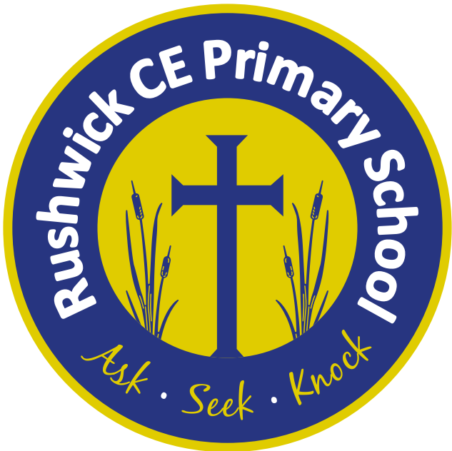
Rushwick CE Primary School: 2025-2026 Long Term Plan
Year 3
 | Autumn 1 | Autumn 2 | Spring 1 | Spring 2 | Summer 1 | Summer 2
Key English text(s) | A River  Blue John | Dare to Care  Mog’s Christmas Calamity | Cinderella of the Nile  Arthur and the Golden Rope | Ask Dr K Fisher  Meet the Artist: Alexander Calder. | Book of Bones | Grendel: A Cautionary Tale about Chocolate
Class novel | Iron Man | Stink Worst Fairy Ever | Stuart Little by E.B White | Leon and the Place Between  Nothing to See Here Hotel | Stitch Head | Firework Makers Daughter
Reading Gems Texts | The Human Skeleton/Five Human Senses Stone Age Boy  Mexican Folk Tales  Hunter-gatherers | On the Day of the Dead/The Last Leaf  Counties and Regions of England/Capital Cities of the UK  Edmund Hilary’s amazing achievement/A giant leap for mankind | Arabian Peninsula/The Yucatan Peninsula  Join our wicked crew/Help our heroes in the Crimean war!  King Midas and the golden touch/The boy who cried wolf | A voyage of Discovery/The great adventurer  Africa/The world  Hansel and Gretel/Mabel’s Egyptian Adventure | Arctic Ocean/Atlantic Ocean  How were the dead mummified/Why do we have four seasons?  The royal escape/Escape the fire | Jane’s Jungle Journey/Florence Nightingale  The centipede song/The Tummy Beast  Rocks/Deciduous and evergreen trees
Poems | If I Were King  By A.A Milne | How the Grinch Stole Christmas by Doctor Seuss | Beautifully Different, Wonderfully the Same - Joseph Coelho | ‘All the worlds alive again’- Jennifer Gunner. | I Raised My Hand In Class | The Ning Nang Nong – Spike Milligan
Maths - White Rose | Place Value  Addition & Subtraction | Addition & Subtraction continued  Multiplication & Division | Multiplication and Division  Length and Perimeter | Fractions  Mass and Capacity | Fractions  Money  Time | Time (Continued)  Shape  Statistics
Science | Rocks – Why are there different rocks? | Plants - What do different parts of a plant do? | Animals including humans - How can animals move? What is in food? | Light - What is a shadow? | Forces - How do moving objects slow down? What materials are attracted to magnets?
Geography |  | Extreme Earth |  | The United Kingdom | Heritage Project Focus: Malvern  Rushwick/Worcester within the UK
History | Stone Age to Iron Age |  | The Ancient Egyptians |  | Heritage Project Focus: Malvern  Rushwick/Worcester within the UK
Music | Ballads | Creating compositions in response to an animation (Mountains) | Pentatonic melodies and composition Theme: Chinese New Year | Developing singing technique  Theme – The Vikings | Jazz | Traditional instruments & improvisation  Theme: India
Art | Drawing:  Cave Paintings  Growing artists |  | Egyptian Scroll – making Papyrus paper and decorating with Egyptian symbols. |  | Sculpture & 3D: Abstract shape
D.T. |  | Wearable technology |  | Structures: Constructing a castle |  | Cooking and nutrition: Eating seasonally
Computing | 1. Computing systems and networks – Connecting computers | 2. Creating media - Stop-frame animation | 3. Programming A - Sequencing sounds | 4. Data and information – Branching databases | 5. Creating media – Desktop publishing | 6. Programming B - Events and actions in programs
R.E. | L2.2 What is it like for someone to follow God? | L2.3 What is the ‘Trinity’ and why is it important for Christians? | L2.1 What do Christians learn from the Creation story? | L2.4 What kind of world did Jesus want? | L2.10 How do festivals and family life show what matters to Jews? | L2.11 How and why do people mark the significant events of life? Christians, Hindus, Muslims, non-religious
P.S.H.E. | Me and My Relationships | Valuing Difference | Keeping Safe | Rights and Respect | Being my Best | Growing and Changing
French | France  Greetings and name | Classroom instructions  French alphabet | Numbers 0 to 20 | The Colours  Numbers 20 to 50 | The Date and Birthday  The Hungry Caterpillar | My Family  At the Farm
P.E./Games | Hockey  Fundamentals | Tag Rugby  Fitness | Dance  Football | Cricket  Gymnastics | Tennis  Netball | Athletics  Basketball

